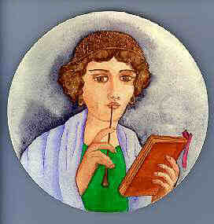
Reading and writing the Roman way
Roman lady with stylus (Illustration by Roy Fern)
Most people could not read or write, because of a lack of education and because books were very expensive. Latin was the spoken and written language of international communication, government and trade, and was introduced into Northern Europe by the Romans.
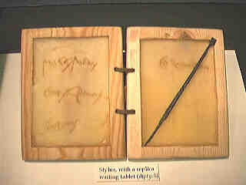
A Roman stylus with reproduction wax tablet
Paper was expensive in Roman times and was only used for important documents and contracts. Most people did their writing on wooden and wax tablets. These consisted of wooden leaves which were strung together. A shallow recess in the wood was filled with wax, which was used as the writing surface.
The writing on the wax was done with a stylus, which was usually made of iron, but could be of bronze or bone. A stylus has a pointed end for writing and a flat end for erasing.
A writing tablet with two wooden leaves was most common and was called a diptych. With three wooden leaves it was called a triptych and if it had more than three leaves it was a polyptychon.

Seal boxes
These were used to protect the contents of the writing tablet from prying eyes. A cord was wrapped around the document and through holes in the side of the box. Wax was then poured into the box and impressed with a seal, perhaps from a finger-ring. The lid was closed and the seal was then protected.
Seal boxes were generally made of bronze and came in many different shapes, often with elaborate enamelled decoration.

Roman Graffiti
Examples of Roman writing can be found in some strange places, such as scratched into the sides of pots.
Fragments of pottery have been found at Rocester with names scratched into their surface. These are the names of the owners of the pots which they were identifying as their own.
Graffiti was usually written in 'cursive' writing which was a more popular and quicker form of the 'official' type of writing used for inscriptions and documents. It is often very hard to read.

Name-stamps
Another place to see Roman writing is on the name-stamps that were applied by pottery makersto their products, such as mortaria or samian ware
Source: http://www.stokemuseums.org.uk/collections/browse_collections/Local_History_Collections/roman_britain/readingandwriting

